One Digital Programme Evaluation

Background
One Digital is a national programme of activity designed to support the development of basic digital skills.
Right now 800,000 people in Scotland, and 50% of all charities lack these skills.
SCVO are delivering three different interventions to help third sector organisations to understand the issues around using digital, and to support change.
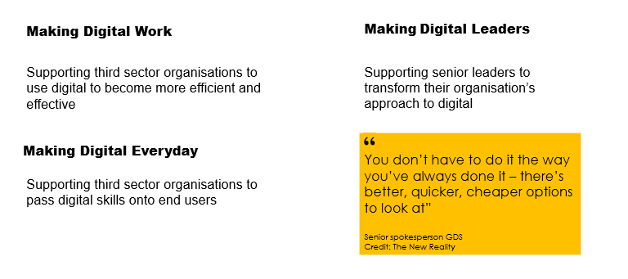
SCVO are working as part of wider consortium with five other organisations. All of the partners are delivering projects designed to increase digital skills and The Big Lottery Fund has funded all of the work.

The Ask
An independent evaluation partner has been appointed to evaluate the overall programme and report back to the Big Lottery Fund. Joint monitoring and reporting tools have been agreed, and the external evaluator will carry out a series of visits and semi-structured interviews.
SCVO are however collecting a significant amount of additional reporting information, and would like to appoint a local evaluation partner to help analyse this and draw out the key lessons from our three specific project interventions.
Our priority interest is the stream of activity focusing on senior leaders. Three facilitated action learning sets are running concurrently with seven third sector leaders in each set. These meetings are confidential and designed to give the leaders the opportunity to focus on resolving significant or thorny issues in order to help their organisation embrace digital.
We want to understand more about how effective these sessions have been, and what different factors have influenced this. This learning will help us to guide future plans, for example designing a clearer application process.
The secondary requirement is to review the data and evidence being collected in different formats from the other interventions, and to analyse and present this to help tell the story of digital skills in the third sector. This will also require some primary research with our delivery partners to understand their views about the factors that have influenced the success of the project.

Timeline and budget
We are looking to appoint a partner by June 17th to deliver against the key requirements outlined above. Responses outlining suitability for the work based on previous experience and proposed approach should be sent to onedigital@scvo.org.uk by 3rd June 2016.
The work can be started from June 20th. We require the final evaluation information by mid-September to feed into wider programme evaluation. We will work with the successful candidate to agree a programme of activity and interim reporting requirements as part of the set-up phase.
More information about the project outcomes and current evaluation approach is available to interested parties on request.
The budget for this work is between £10,000 and £20,000 inc VAT.

